Data from Leaf Node #3

This node was deployed in our backyard on 28 April 2021 and ran until 7 Jan 2022.

It was in the backyard, buried with the sensor about 1 inch under the soil. The plotted values are from the SD card in the note. It also sent data to a LoRa receiver in the house but I have not looked closely at those. They seem to be the same, however, at first glance.

The leaf node was configured to sample once every 5 mins (301 secs) and made 72,468 samples before stopping - equivalent to a little more than 8 years of operation at one sample per hour.

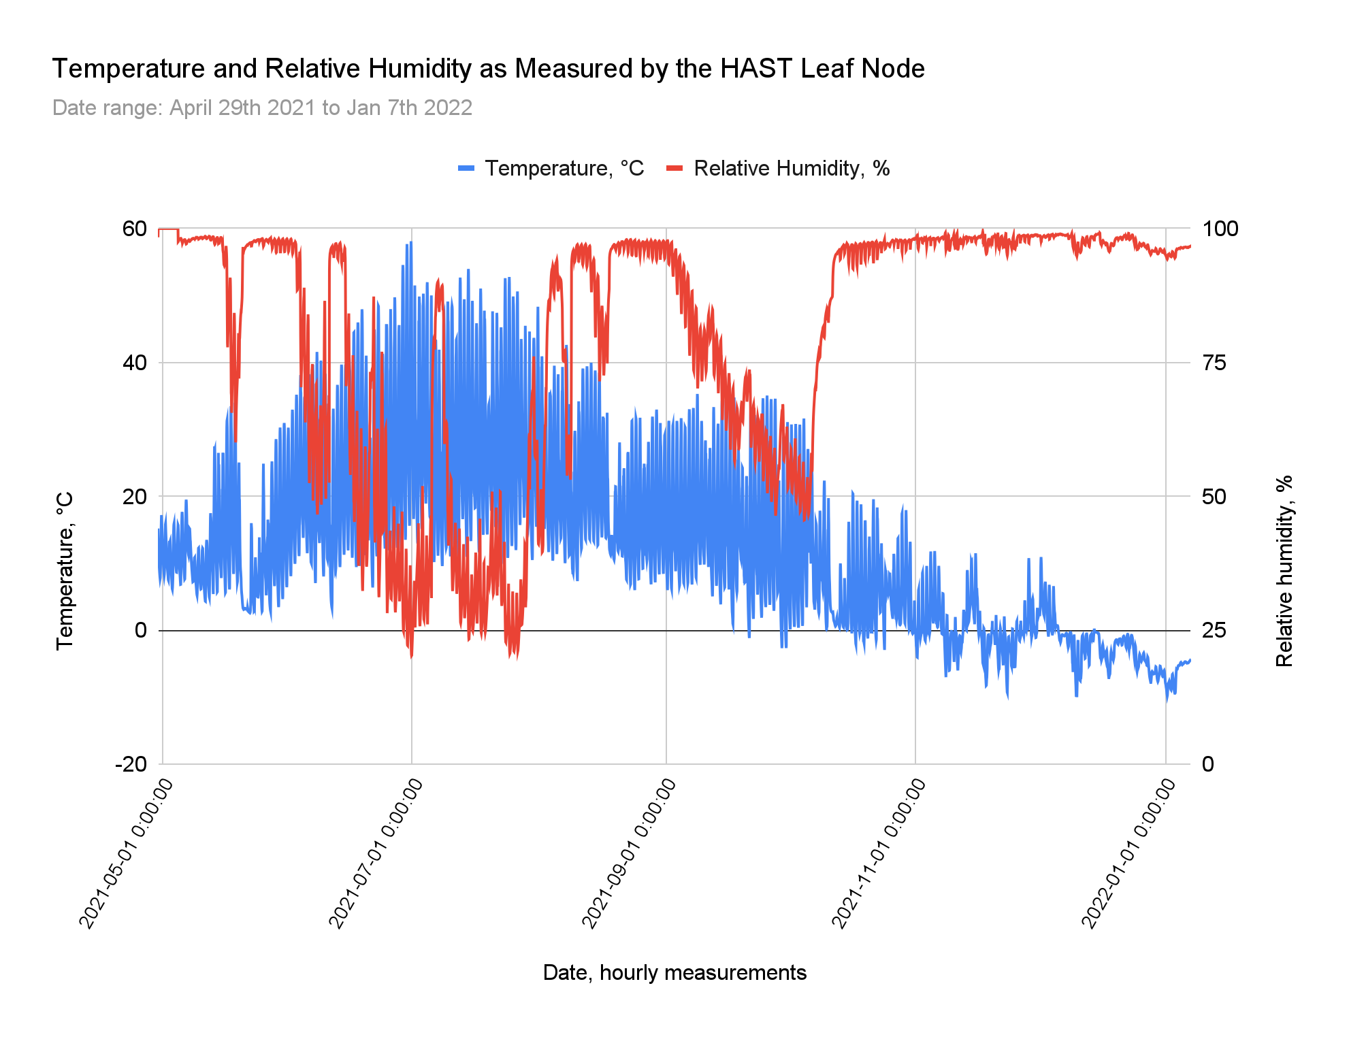

After I opened the node's enclosure, I measured the battery voltage at 3.1 v.

The inside of the enclosure was dry but did have three spots. The board, electronics and batteries appear untouched. There is no sign of water damage (or any damage).

The last entry in the SD cards CSV file is a timestamp of Monday, April 19, 2038 7:34:14 AM. Note the year, 2038. I think the leaf-main node communication was garbled and the leaf node reset its clock to the wrong date and time. The leaf-main node interactions need to be made more robust! There was no error reported.

Unfortunately, this version of the leaf node PCB (0.4) did not have reliable battery voltage measurement, so there's now way to tell if the battery lost voltage or not. The 0.5 board has better battery voltage measurement, so we might get more information from the node that's currently frozen in the ground.

Some photos:

The node just after I dug it up and on the workbench showing the battery voltage.

|  |  |
| --- | --- |